7562 N. La Cholla Blvd., Tucson, AZ 85741 (520) 498-9984
www.drcasabona.com

HOME EXERCISES: DEAD BUG

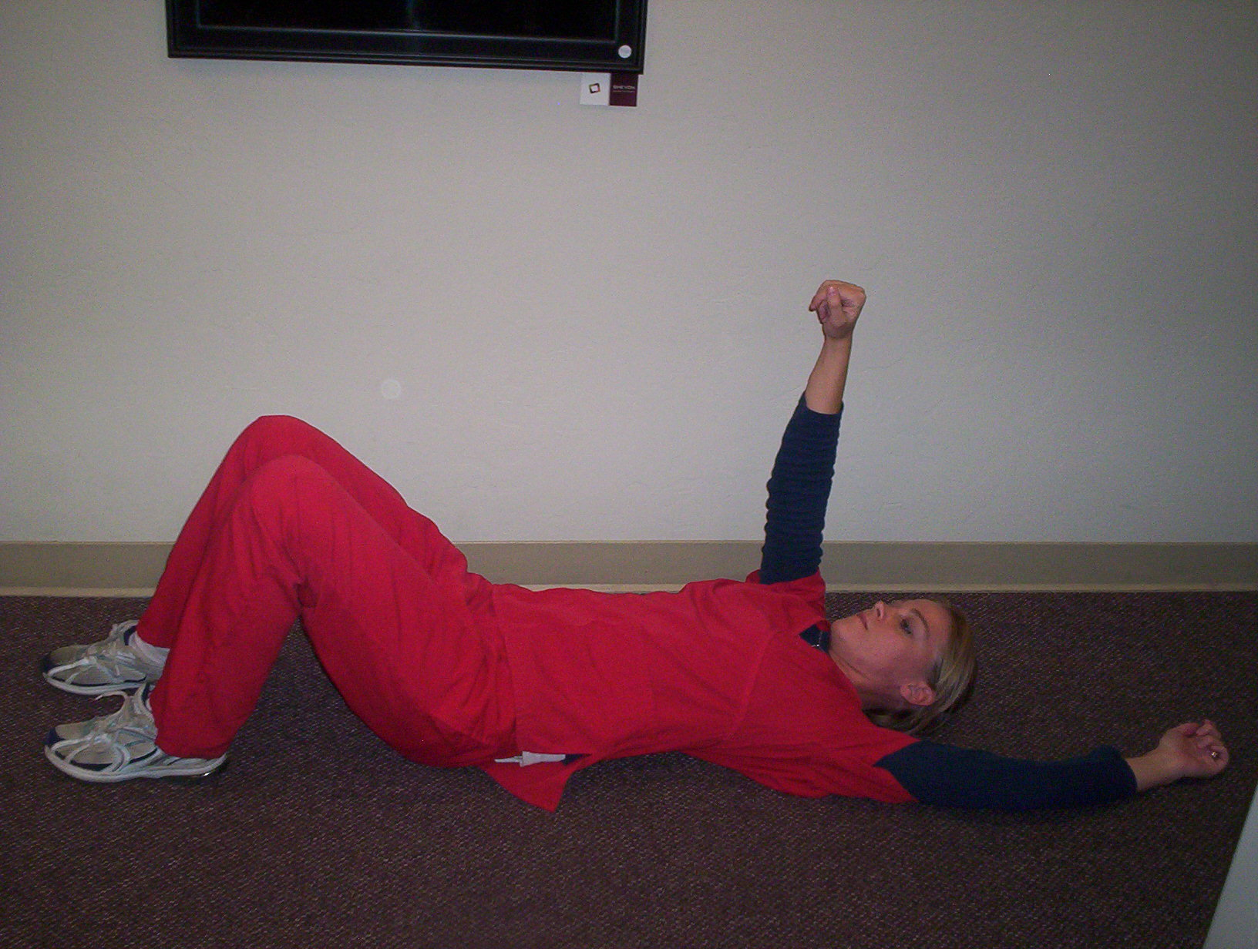
Beginner:
- Lie flat on your back, arms and legs extended
- Pull belly button in, towards the spine
- Raise one arm up
- Hold for 2 seconds then drop arm
- Raise one leg (with knee bent)
- Hold for 2 seconds then drop leg
- Return to the starting position
- Switch to the opposite arm and leg and repeat
Do 40 repetitions (20 on each side), 1-2 times per day.

Intermediate:
- Lie flat on your back, arms and legs extended
- Pull the belly button in, towards the spine
- Raise the alternate arm and leg (with knee bent)
and lift your head (chin to chest)
- Hold for 2 seconds
- Return to the starting position
- Switch to the opposite arm and leg and repeat
- Try to increase the number of seconds that you hold the position
Do 50 repetitions (25 on each side), 1-2 times per day.

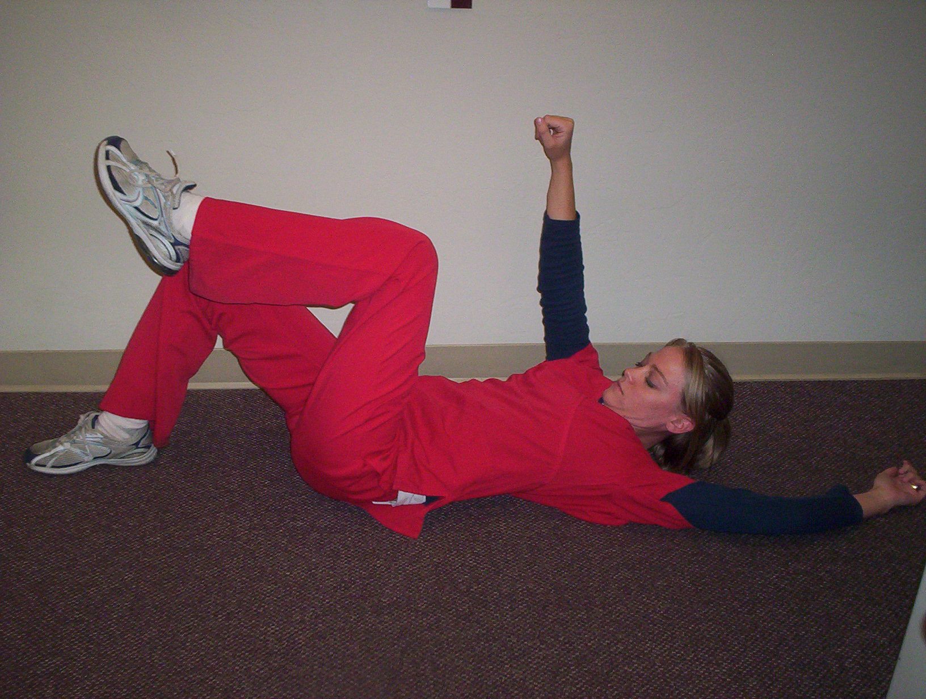

Advanced:
- Lie on your back, arms and legs extended
- Pull belly button in, towards the spine
- Raise both arms and legs
- Hold for 2 seconds
- Return to the starting position
- Repeat
- Try to increase the number of seconds that you hold the position
Do 60 repetitions, 1-2 times per day.

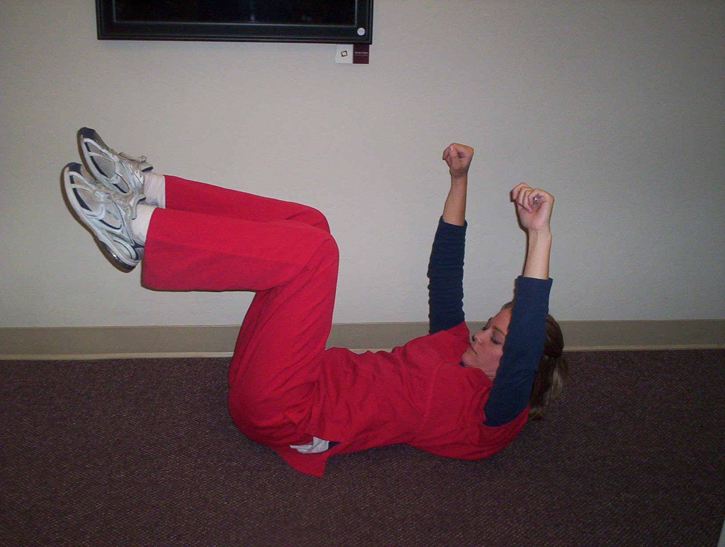
7562 N. La Cholla Blvd., Tucson, AZ 85741 (520) 498-9984
www.drcasabona.com
HOME EXERCISES: SUPERMAN
Beginner:
- Lie flat on your stomach, arms and legs extended.
- While face down, raise one arm and hold for 2 seconds. Bring your arm down.
- Continue raising one arm or leg at a time, holding for 2 seconds each time, and return to the starting position
Do 40 repetitions (20 on each side), 1-2 times per day.
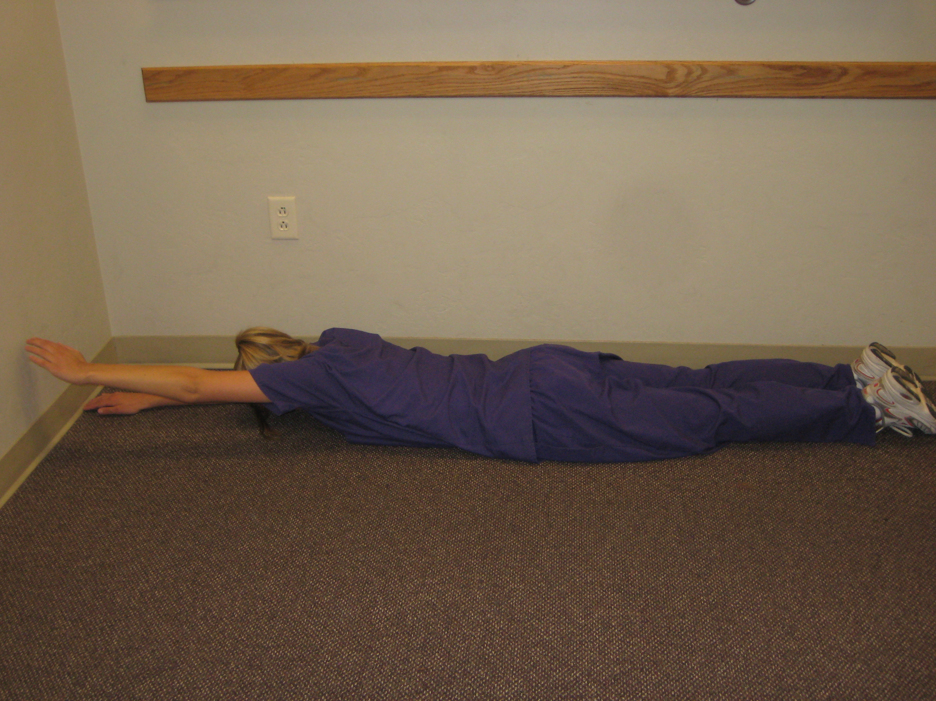

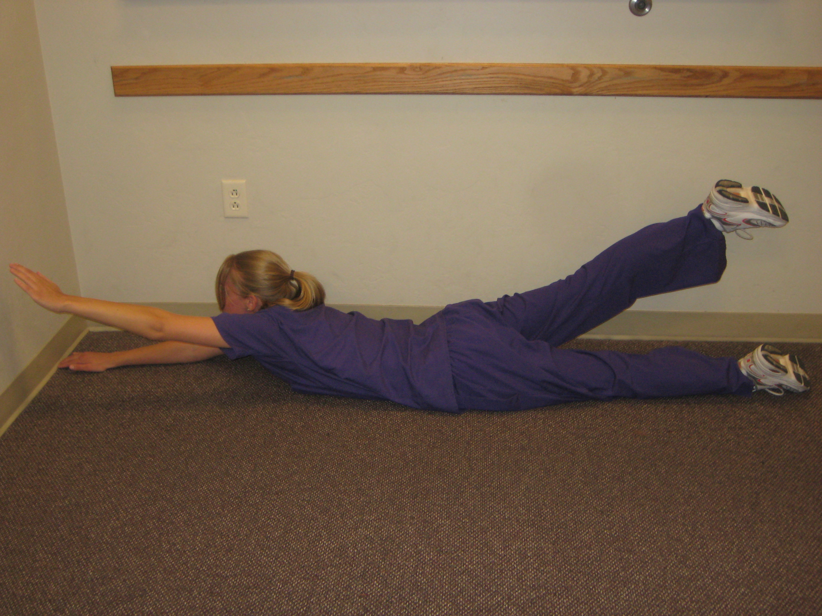
Intermediate:
- Lie flat on your stomach, arms and legs extended
- Raise an alternate arm and leg and lift your head to look up at the ceiling
- Hold for 2 seconds and return to starting position
- Repeat with the alternate arm and leg. Try to increase the length of time that you hold the position.
Do 50 repetitions (25 on each side), 1-2 times per day.

Advanced:
- Lie on your stomach
- Raise both arms and legs. Lift your head to look up at the ceiling
- Hold for 2 seconds and return to starting position
- Repeat
- Try to increase the length of time that you hold the position
Do 60 repetitions, 1-2 times per day.

