Home exercises
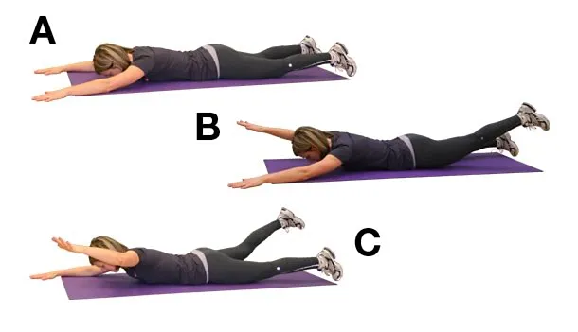
Superman: Start with laying on your stomach, arms extended above your head. Lift opposite arm/ opposite leg. (5-6 sets of 10)

Deadbug: Start laying on your back with arms and legs lifted as shown in the picture below. Lower opposite arm/ opposite leg. (5-6 sets of 10)
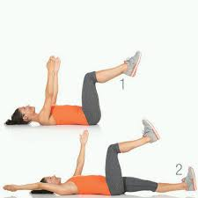

Side plank with dips: Start in a side plank. Lower and lift your pelvis (5-6 sets of 10)

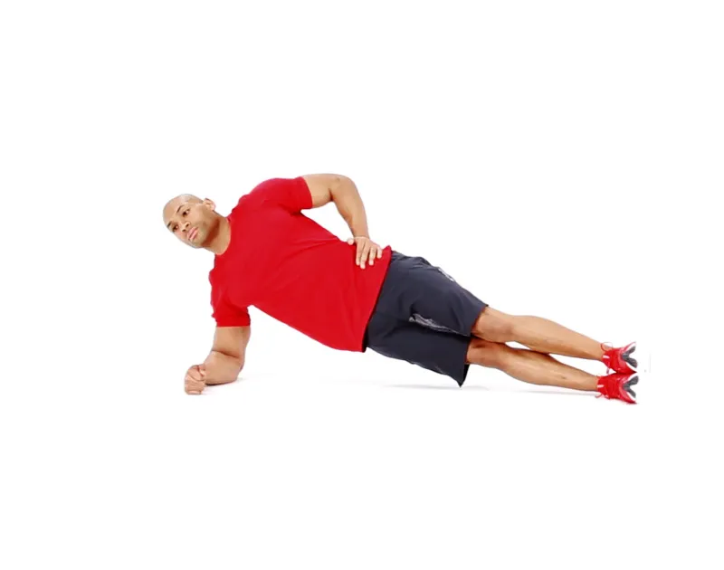
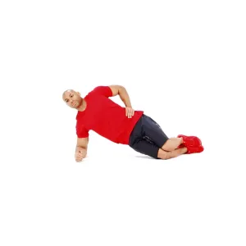
Regular version Modified version: Bent knees

Begin with laying on these rollers for 3 minutes a day, on under the neck and one under the low back. Increase the time by a minute everyday until you have reached 15-20 minutes.
